
Project Id: 2024MP_CSEPID011
Mini Project Synopsis
on
PrayasAI Disha
AI-Powered Personalized Internship Recommendation and Skill Gap Analysis System
Submitted in Partial Fulfillment of the Requirement
For the Degree of
Bachelor of Technology
In
Computer Science and Engineering
By
Kartikeya Verma (2402900100149)
Keshav Mittal (2402900100152)
Khushi Bhati (2402900100153)
Karthik Singhal (2402900100147)
Under the Supervision of
Satyendra Singh
Professor
Department of Computer Science Engineering
ABES INSTITUTE OF TECHNOLOGY, GHAZIABAD
AFFILIATED TO

Dr. A.P.J. ABDUL KALAM TECHNICAL UNIVERSITY, UTTAR PRADESH, LUCKNOW
(ODD SEM, 2026-27)

Table of Contents
Chapter No. | Contents | Page No.
1 | Abstract | 3
2 | Introduction | 4
3 | Literature Survey | 5-7
4 | Problem Statement | 8
5 | Proposed Methodology | 9-12
6 | Implementation & Results | 13-14
7 | Mapping with SDG Goal | 15
8 | Conclusion/Future Scope | 16
9 | References | 17-18

1. Abstract
Students searching for internships often face a large number of opportunities with different domains, eligibility conditions, locations, descriptions, and skill requirements. Manual comparison of these opportunities with an individual student's academic background, skills, interests, and preferences can be time-consuming and may not consistently identify the most relevant options. PrayasAI Disha is proposed as a web-based AI-powered personalized internship recommendation and skill gap analysis system developed in the context of the AI-based internship recommendation problem represented by SIH problem statement SIH25034. The system analyzes student-profile information and internship-related information to determine compatibility. Natural Language Processing techniques are used to represent suitable textual attributes through Term Frequency–Inverse Document Frequency (TF-IDF), while cosine similarity provides a measure of textual/profile similarity. A weighted recommendation approach can combine relevant matching factors such as skill similarity, academic or branch relevance, interest matching, and internship requirement compatibility. The system also performs skill-gap analysis by comparing a student's existing skills with the skills required by relevant internship opportunities. The proposed web architecture uses React.js and Tailwind CSS for the frontend, Flask REST APIs for the backend, and MySQL for persistent data storage. The project is intended as an academic prototype and is currently under development; therefore, final accuracy, performance, deployment, and real-world impact are not claimed.
Keywords: Internship Recommendation, Skill Gap Analysis, Natural Language Processing, TF-IDF, Cosine Similarity, Personalized Recommendation, React.js, Flask, MySQL

2. Introduction
Internships provide students with opportunities to gain practical exposure, understand workplace expectations, and connect academic learning with professional skills. However, the process of finding an appropriate internship can become difficult when students are presented with many opportunities that vary in domain, organization, location, eligibility, required skills, and role description. The challenge is not only to locate internship listings, but also to determine which opportunities are relevant to an individual student's current profile and future interests.
A common approach to internship discovery is manual searching through job or internship portals, followed by reading individual descriptions and comparing them with personal skills and eligibility. This process requires repeated effort and may make it difficult for a student to identify the most suitable opportunities efficiently. The problem becomes more significant when internship descriptions contain unstructured text and when the same skill may be expressed using different words or phrases.
Recommendation systems provide a computational approach for reducing information overload by filtering and presenting items that are more relevant to a user's profile. In an internship setting, the items are internship opportunities, while the user profile may contain academic background, branch, skills, interests, and preferences. Content-based techniques are particularly relevant because they can compare characteristics of a user's profile with textual or structured attributes of available opportunities. Recent literature on internship and job recommendation systems discusses content-based filtering, collaborative filtering, hybrid approaches, similarity measures, and skill-oriented matching.
Natural Language Processing (NLP) can be used to process textual information such as skill descriptions and internship requirements. TF-IDF is a classical and interpretable method for representing the importance of terms in documents. After transforming profile and internship text into numerical vectors, cosine similarity can be used to estimate how closely the two representations are aligned. These techniques are suitable for an academic prototype because they provide a transparent baseline for text-based matching without requiring a large deep-learning training pipeline.
In addition to recommendation, a useful internship-support system should help a student understand why an opportunity may or may not fit the current profile. Skill-gap analysis addresses this requirement by comparing the student's known skills with the skills required by relevant internship opportunities. The output can distinguish matched skills from missing or improvement-oriented skills. Such information can help a student understand the requirements of a target internship rather than simply receiving a list of opportunities.
PrayasAI Disha is proposed in this context as an AI-powered personalized internship recommendation and skill gap analysis system. The project is inspired by the PM Internship Scheme problem domain and the SIH problem statement SIH25034. It is important to clarify that PrayasAI Disha is a student-developed academic prototype and is not being presented as an official Government of India application, an adopted Ministry of Corporate Affairs platform, or an officially integrated component of the PM Internship portal.
The proposed system follows a layered web architecture. A React.js and Tailwind CSS frontend collects and displays information for the user. A Flask-based backend exposes REST APIs and coordinates communication between the frontend, database, and recommendation components. MySQL is used for persistent storage. The recommendation engine performs preprocessing, feature extraction, similarity calculation, weighted matching, and skill-gap analysis before producing recommendation results for presentation through the web interface.
The project therefore combines software engineering, database management, web development, information retrieval, and basic machine-learning/NLP techniques into a single academic system. The current development work includes the Flask backend, MySQL connectivity and database setup, React frontend development, and recommendation-module development. Components that require final data acquisition, comprehensive testing, performance evaluation, or deployment remain under development and are treated as proposed or future work rather than completed outcomes.

3. Literature Survey
The literature survey focuses on research related to job and internship recommendation, profile-to-opportunity matching, NLP-based recommendation, and skill-oriented career support. The selected works were verified against publisher or academic-index pages and were chosen because their methods or findings are directly relevant to the design of PrayasAI Disha.
S. No. | Author(s) & Year | Title of Paper / Work | Objective / Focus | Methodology / Approach | Key Findings
1 | Poncio (2024) | Navigating techniques in job recommender systems on internship profile matching: A systematic review | Reviews methods used for internship/job recommender systems, profile evaluation, and suggestion/ranking. | Systematic review of data collection, filtering techniques, similarity/ranking approaches, and evaluation methods. | Reports that primary profile data can improve personalization and that hybrid approaches can mitigate limitations of individual filtering methods.
2 | Kumar, Gupta, Sharma, & Ofori (2022) | Technical Job Recommendation System Using APIs and Web Crawling | Automate collection and recommendation of technical job opportunities. | Web crawling and APIs; hybrid content-based and collaborative filtering; TF-IDF and cosine similarity are used within the matching process. | Demonstrates a web-based job recommendation workflow and emphasizes reducing the burden of manually searching numerous technical job sources.
3 | Alsaif, Sassi Hidri, Eleraky, Ferjani, & Amami (2022) | Learning-Based Matched Representation System for Job Recommendation | Recommend jobs by matching job-seeker skills with job-listing features. | Content-based filtering and NLP-based matching of resume/profile information with job listings; evaluation of recommendation performance. | Shows the usefulness of skill-oriented matching and a web-based recommendation design for handling large numbers of job listings.
4 | Rajput, Dubey, Thakur, Singh, & Singh (2024) | Career Craft AI: A Personalized Resume Analysis and Job Recommendations System | Combine resume/profile analysis with personalized job recommendation and career support. | NLP, profile classification, cosine similarity, and recommendation using skills and profile information. | Illustrates how profile analysis and similarity-based recommendation can be combined to provide personalized job suggestions and supporting insights.
5 | Almalki, Al-Alsheikh, Bahareth, Abdullah, & Alsahafi (2025) | BERT-based Job Recommendation System Using LinkedIn Dataset | Improve semantic understanding of job descriptions and user profiles for personalized recommendation. | BERT-based contextual NLP with content-based recommendation using skills and preferences. | Explores contextual semantic matching as an alternative to traditional keyword-oriented methods, highlighting the potential of transformer-based representations.
Table 1. Recent literature relevant to job/internship recommendation and skill matching.

3.1 Literature Gap
The reviewed literature shows that recommendation systems can reduce information overload by matching user profiles with job or internship descriptions. Content-based methods provide an interpretable baseline through textual similarity, while hybrid and semantic approaches can address limitations of simple keyword matching. The literature also shows that internship-specific recommendation remains a distinct application context in which student goals, academic background, skills, and opportunity requirements need to be considered together.
PrayasAI Disha uses this research direction as a practical academic baseline. Instead of depending on a complex deep-learning training pipeline, the proposed system uses TF-IDF and cosine similarity together with conceptually weighted matching factors. It adds an explicit skill-gap analysis stage so that the output is not limited to recommending opportunities but also indicates the skills that may require improvement. The project can later evolve toward semantic embeddings or more advanced NLP methods after sufficient validated data becomes available.

4. Problem Statement

4.1 Description of the Problem Statement
Students often find it difficult to identify internship opportunities that align with their existing skills, academic background, interests, and preferences. At the same time, internship opportunities contain their own eligibility criteria, required skills, domains, descriptions, and other requirements. Manually comparing these two sides across a large collection of opportunities is time-consuming and may not provide a consistent method for identifying relevant options.
Therefore, there is a need for a web-based system that can analyze student-profile information and internship requirements, measure their compatibility, provide personalized internship recommendations, and identify skill gaps between the student's current capabilities and the requirements of relevant opportunities. PrayasAI Disha addresses this problem as an academic prototype in the context of SIH problem statement SIH25034 and the PM Internship Scheme problem domain.

4.2 Objectives
- To develop a web-based personalized internship recommendation system for students.
- To analyze student profiles and internship requirements using structured and textual information.
- To apply TF-IDF and cosine similarity for relevant text-based profile and internship matching.
- To combine relevant compatibility factors through a weighted recommendation approach without assuming fixed weights until they are experimentally finalized.
- To identify skill gaps by comparing student skills with the skills required by relevant internship opportunities.
- To present internship recommendations and skill-gap information through a user-friendly web interface.
- To implement the system using React.js, Tailwind CSS, Python, Flask, Pandas, scikit-learn, and MySQL.
- To establish a scalable academic foundation for future enhancements such as improved semantic matching, validated live data integration, and feedback-based personalization.

5. Proposed Methodology

5.1 System Overview
The proposed PrayasAI Disha system follows a layered architecture in which the frontend collects and presents user information, the Flask backend coordinates application logic, the recommendation engine performs matching and skill-gap analysis, and the MySQL database stores structured information. The conceptual processing flow is: Student Profile → Data Processing → Feature Extraction → Similarity Calculation → Weighted Matching → Skill Gap Analysis → Recommendation → User Interface.

5.2 Technology Stack
Layer | Technology | Purpose
Frontend | React.js, Tailwind CSS, JavaScript, HTML5 | Responsive user interface, profile forms, internship display, and result presentation.
Backend | Python, Flask, Flask REST APIs | Application logic, API endpoints, validation, and coordination between modules.
Database | MySQL | Persistent storage for student, internship, and related structured information.
AI/ML | Python, Pandas, scikit-learn | Data preparation, feature processing, similarity computation, and recommendation logic.
Recommendation | TF-IDF, Cosine Similarity, Weighted Recommendation | Text representation, similarity measurement, and combined compatibility scoring.
Table 2. Technology stack of PrayasAI Disha.

5.3 System Architecture
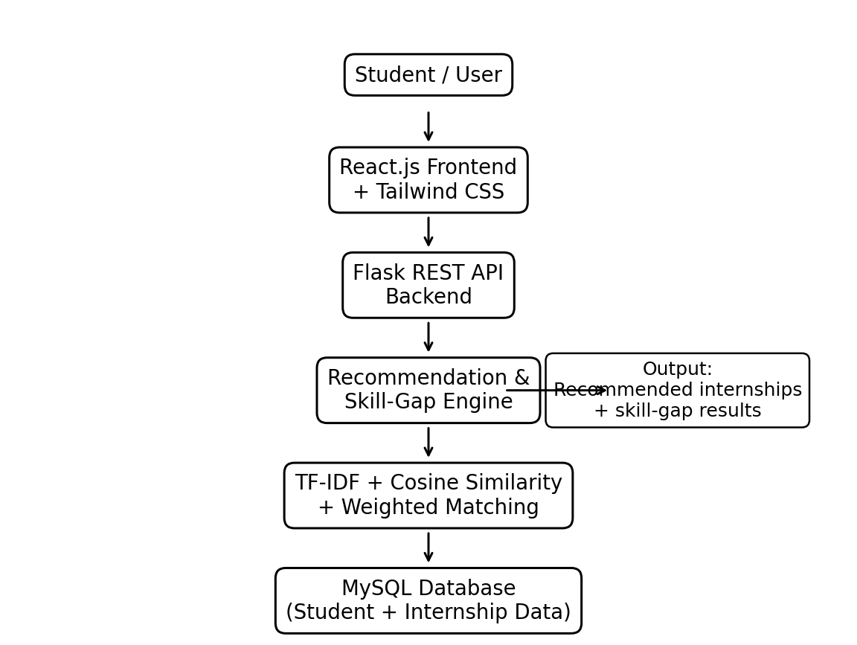
Figure 1. Proposed system architecture.
The architecture deliberately places MySQL behind the Flask backend. The React frontend communicates with Flask REST APIs rather than connecting directly to the database. The recommendation and skill-gap engine is invoked through backend application logic and uses processed student and internship information.

5.4 Data Flow
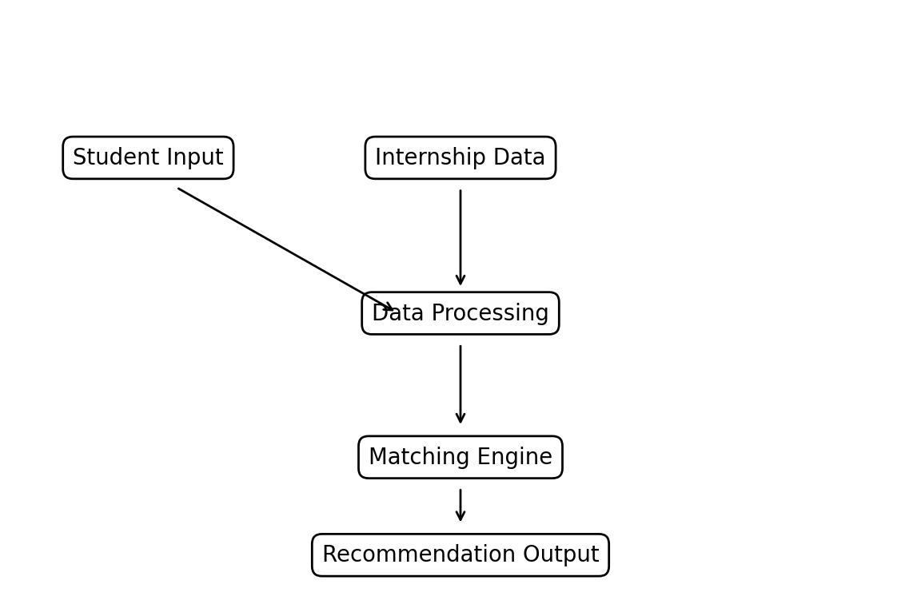
Figure 2. High-level data flow.
The system receives student information and internship-related information as inputs. These inputs are normalized and processed before entering the matching engine. The resulting recommendation and skill-gap information is returned through the backend to the frontend for presentation.

5.5 Recommendation Methodology
Stage 1 — Student Profile: The student provides relevant information such as branch or discipline, skills, interests, preferences, and academic information. Only information required by the implemented application should be collected.
Stage 2 — Internship Data: Relevant internship information is represented using attributes such as internship title, organization, sector/domain, location, eligibility, required skills, description, and other available requirements. The final data-acquisition method is dependent on the validated source and implementation status.
Stage 3 — Data Preprocessing: Textual fields are cleaned and normalized so that profile and internship descriptions can be compared more consistently. Appropriate preprocessing may include case normalization, whitespace handling, removal of irrelevant tokens, and preparation of skill phrases.
Stage 4 — Feature Extraction: TF-IDF converts suitable textual information into numerical vectors. The technique assigns higher importance to terms that are informative within a document while reducing the influence of terms that occur frequently across many documents.
Stage 5 — Similarity Calculation: Cosine similarity is applied to compare the student representation with internship representations. A higher similarity indicates greater alignment in the represented textual features, subject to the limitations of lexical matching.
Stage 6 — Weighted Recommendation: The system can combine multiple compatibility factors, such as skill similarity, academic or branch relevance, interest matching, preference compatibility, and internship requirement compatibility. Exact weights should be finalized only after implementation and testing; no unsupported fixed percentages are claimed in this synopsis.
Stage 7 — Recommendation Output: The system presents relevant internship opportunities to the student using the computed recommendation scores or ordering. The final presentation should explain the main matching factors where the implemented interface supports such explanations.

5.6 Skill Gap Analysis
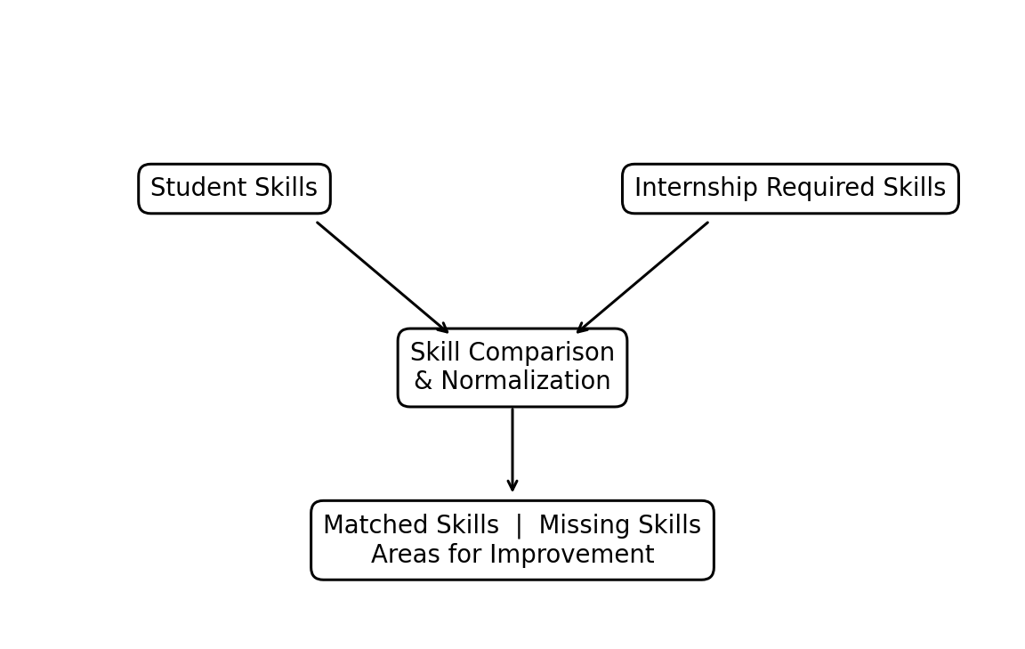
Figure 3. Skill-gap analysis flow.
Skill-gap analysis compares the student's existing skills with the skills required by relevant internship opportunities. The comparison can identify matched skills, missing skills, and areas for improvement. The module is intended to provide actionable information about the requirements of a target opportunity. It does not automatically teach the missing skills unless a separate learning-resource module is implemented.

5.7 Modules
Module | Function
1. Student Profile Management | Collects and manages relevant student information required for recommendation.
2. Internship Data Management | Stores and manages structured internship information and associated requirements.
3. Data Preprocessing | Prepares textual and structured information for consistent comparison.
4. Recommendation Engine | Applies TF-IDF, cosine similarity, and weighted matching logic.
5. Skill Gap Analysis | Compares student skills with internship requirements and identifies missing or improvement-oriented skills.
6. Backend API | Provides Flask REST endpoints and coordinates application modules.
7. Database | Uses MySQL for persistent storage of system information.
8. Frontend | Uses React.js and Tailwind CSS for user interaction and presentation.

5.8 Flowchart
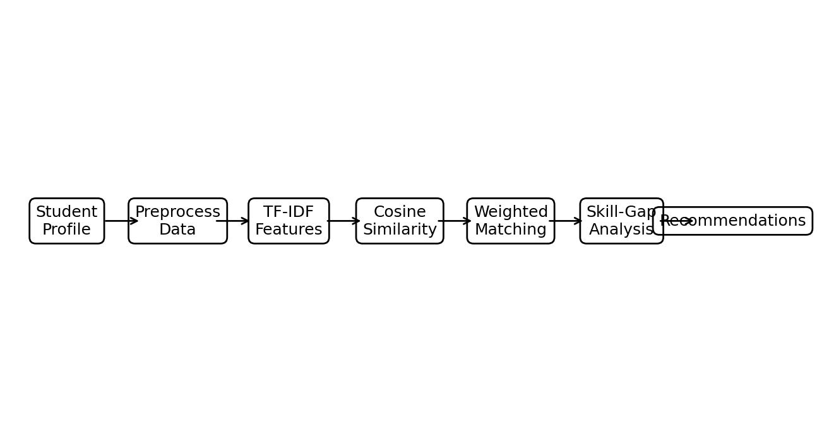
Figure 4. Overall recommendation workflow.
The flowchart summarizes the end-to-end recommendation process from student profile input through preprocessing, feature extraction, similarity computation, weighted matching, skill-gap analysis, and final recommendation output.

6. Implementation & Results

6.1 Implementation
The project is being implemented as a web-based academic prototype. The backend is being developed in Python using Flask and Flask REST APIs. The MySQL database named prayasai_disha has been configured for development, and database connectivity has been tested in the development environment. The frontend is being developed using React.js and Tailwind CSS. The AI/ML module is being developed using Python, Pandas, and scikit-learn with TF-IDF, cosine similarity, and weighted recommendation logic.
The project repository contains the development work for the PrayasAI Disha application, including backend-related work and database integration. Team responsibilities are distributed across backend and coordination, database design, AI/ML integration, and frontend development. The implementation is iterative, so individual modules may reach different levels of completion during development.

6.2 Current Development Status
Component | Status | Description
Flask Backend | Implemented / under development | Backend environment and application structure are being developed; API modules remain subject to ongoing integration.
MySQL Database | Configured / tested | Development database prayasai_disha and database connectivity have been configured and tested.
React Frontend | Under development | Frontend structure and user-facing components are being developed.
Recommendation Engine | Under development | TF-IDF, cosine similarity, and weighted matching logic are being integrated.
Skill Gap Analysis | Under development | Skill comparison logic is being developed as a dedicated recommendation-support component.
Internship Data Acquisition | Under development | Validated data acquisition from the PM Internship Scheme domain remains subject to implementation and source/API verification.
Final Evaluation | Pending | Quantitative accuracy, precision, recall, F1, response-time, and user-study results have not been finalized.
Table 3. Current implementation status.

6.3 Expected / Available Results
The intended functional result is a personalized set of internship opportunities that are compatible with the student's profile, together with a skill-gap view that identifies skills already matched and skills that may require improvement. The frontend is expected to present these outputs in an understandable format after the backend and recommendation components are fully integrated.
At the current synopsis stage, final quantitative evaluation results are not available. Accordingly, this document does not claim recommendation accuracy, precision, recall, F1-score, dataset size, number of users, number of internships, response time, deployment statistics, or recommendation success rate. Such values should be added only after the team completes reproducible testing and records the actual measurements.
Suggested screenshots for the final project report, once the corresponding modules are actually implemented, include: student profile form, internship listing/data view, recommendation results, skill-gap results, backend API response, and MySQL database structure. Screenshots should be inserted only for features that exist in the final build.

7. SDG Goals Mapping
The United Nations Sustainable Development Goals provide a framework for relating technology projects to broader social and developmental objectives. The relationship below is based on the actual scope of PrayasAI Disha rather than on a generic list of SDGs.
SDG | Relevance to PrayasAI Disha | Nature of Contribution
SDG 4 – Quality Education | Primary | The system can help students understand internship requirements, identify relevant opportunities, and recognize skills that may need further development, supporting practical and career-oriented learning.
SDG 8 – Decent Work and Economic Growth | Primary | The project focuses on internship discovery and employability-related skill alignment, supporting students in navigating opportunities connected with professional development.
SDG 10 – Reduced Inequalities | Secondary / conditional | If designed and made accessible across student groups, personalized matching can help reduce information-access barriers. This relationship should be presented as a potential contribution rather than a proven impact.
Table 4. Mapping of PrayasAI Disha with selected SDGs.
The primary SDG alignment is with SDG 4 and SDG 8 because the system directly addresses learning-to-opportunity alignment and internship/employability support. SDG 10 is treated as a secondary and conditional connection because reduced inequality would depend on how the system is made accessible and how fairly opportunities are represented in the underlying data.

8. Conclusion and Future Scope

8.1 Conclusion
PrayasAI Disha proposes a web-based approach to personalized internship discovery and skill-gap analysis. The system addresses the practical difficulty of comparing a student's skills, academic background, interests, and preferences with the requirements of numerous internship opportunities. The proposed methodology combines NLP-based text representation through TF-IDF, cosine similarity for profile-to-opportunity comparison, and a weighted recommendation approach for incorporating multiple compatibility factors.
The system is designed as a layered application using React.js and Tailwind CSS on the frontend, Flask REST APIs and Python on the backend, and MySQL for persistent storage. A dedicated skill-gap analysis component complements the recommendation process by identifying skills that match internship requirements and skills that may require improvement. The project is currently under development, so the synopsis intentionally separates implemented development work from proposed functionality and does not claim unverified evaluation results or real-world deployment.

8.2 Future Scope
- Validated integration with live or regularly updated internship data sources, subject to availability, access permissions, and technical feasibility.
- Improved semantic matching using embeddings or advanced NLP techniques after obtaining an appropriate validated dataset.
- Feedback-based personalization that learns from student interactions and recommendation feedback.
- Learning-resource recommendations for identified skill gaps.
- Notification and reminder functionality for relevant internship opportunities.
- Analytics dashboards for students or academic internship coordinators.
- Improved scalability, security, authentication, and deployment architecture.
- Mobile-friendly enhancements and accessibility improvements.
- Comprehensive evaluation using a validated benchmark dataset and suitable recommendation metrics.

9. References
- Almalki, L., Al-Alsheikh, N., Bahareth, F., Abdullah, M., & Alsahafi, R. (2025). BERT-based job recommendation system using LinkedIn dataset. Journal of Information Systems Engineering and Management, 10(8s), 280–291. https://doi.org/10.52783/jisem.v10i8s.1026
- Alsaif, S. A., Sassi Hidri, M., Eleraky, H. A., Ferjani, I., & Amami, R. (2022). Learning-Based Matched Representation System for Job Recommendation. Computers, 11(11), 161. https://doi.org/10.3390/computers11110161
- Kumar, N., Gupta, M., Sharma, D., & Ofori, I. (2022). Technical Job Recommendation System Using APIs and Web Crawling. Computational Intelligence and Neuroscience, 2022, 7797548. https://doi.org/10.1155/2022/7797548
- Poncio, F. P. (2024). Navigating techniques in job recommender systems on internship profile matching: A systematic review. Journal of Research in Innovative Teaching & Learning, 17(2), 352–367. https://doi.org/10.1108/JRIT-01-2024-0016
- Rajput, A., Dubey, A., Thakur, R., Singh, D., & Singh, U. P. (2024). Career Craft AI: A personalized resume analysis and job recommendations system. In Proceedings of the 2024 1st International Conference on Innovative Sustainable Technologies for Energy, Mechatronics, and Smart Systems (ISTEMS), 1–6. https://doi.org/10.1109/ISTEMS60181.2024.10560126
- Ministry of Corporate Affairs, Government of India. (n.d.). PM Internship Scheme portal. https://pminternship.mca.gov.in/

